Day 1 :
Receipt and Invoice Digitizer
A software tool that converts paper-based or unstructured digital financial documents (like PDFs or photos) into structured, machine-readable digital data. It goes beyond simple scanning by using Optical Character Recognition (OCR)

How OCR Works
OCR systems use a combination of hardware (scanners) and software to recognize text.
- Preprocessing: The software cleans up the image (removing noise, increasing contrast) to improve recognition.
- Feature Extraction: The system analyses character shapes (patterns).
- Recognition: Algorithms identify letters, words, and sentences.
- Post-processing: Advanced systems (using AI/Deep Learning) correct errors to ensure high accuracy.

Day 2 :
Creating git hub repository
Creating personal repository using MIT licence ,git ignore and readme file
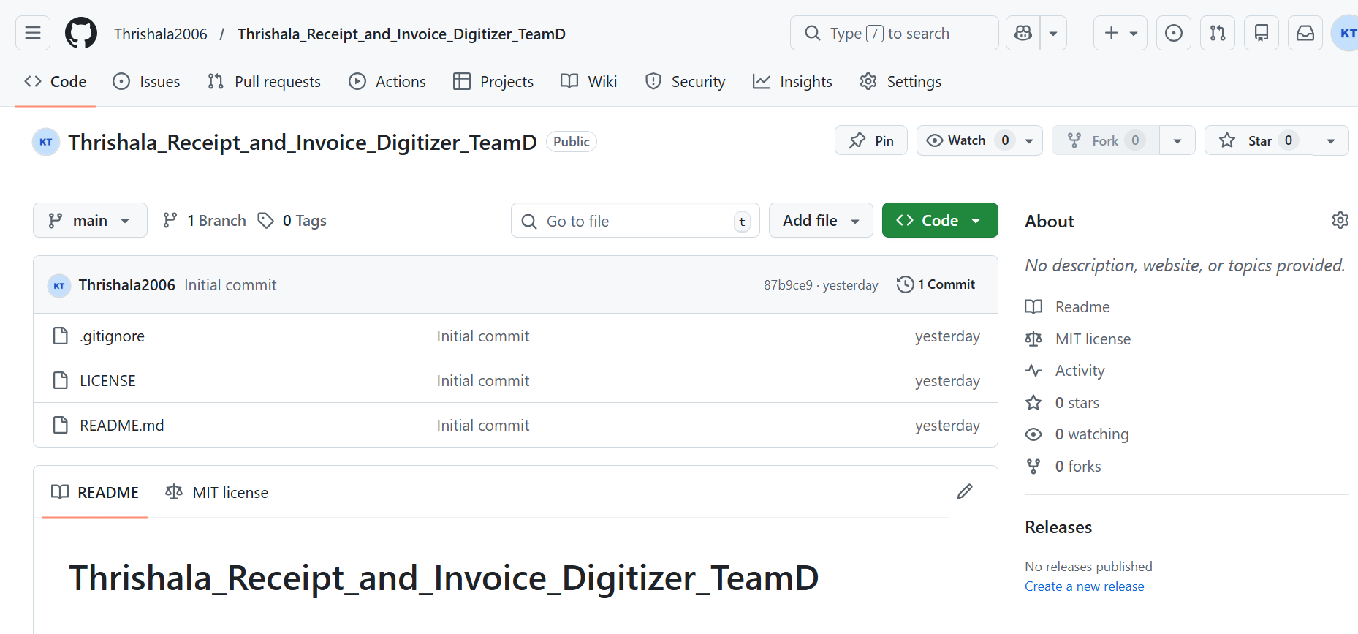

Day 3 :
Difference between git ,github ,gitlab
Git : it is versioncontrol and used to run commands
Github : cloudplatform where we can create our own repository
Gitlab: it is deployment platform used for deployment of codes
Git hub commands
- git branch: Lists all local branches in your current repository
- git branch -a: Lists all branches, including both local and remote-tracking branches.
- git checkout <branch_name>: Switches your working environment to an existing branch.
- git checkout -b <new_branch_name>: creates a new branch and immediately switches to it
- git add.: Stages all modified and new files in the current directory for the next commit.
- git add filename : Stages only the specific file you named.
- Git commit -m message : to commit a change
- Git fetch –all : Downloads all objects and references from every remote repository, but does not merge them into your local work.
- git pull :Fetches changes from the remote and immediately merges them into your current local branch.
- git push :Uploads your local branch commits to the remote repository.
how to create a virtual machine
create a virtual machine for python
- Python – m venv filename -> create a virtual environment
- Filename/script/activate -> to activate this file
- Pip install -r requirements.txt -> install all requirement files
- Filename.py ->to run your code
- Deactivate -> to exit from virtual environment

Day 4 :
Software development life cycle (SDLC)
It is a structured step by step process followed to design ,develop, test, deploy and maintaining software
SDLC ROLES:
1.functional consultant or business analysis
They will go to clients or connect with the clients and they gather information from clients
Functional consultant get basic requirements from client and what they are expecting and understands and develop a document called FSD -function specification document

2.developer or programmers
They know what technologies are required and so prepare Technical specification document and they mention what technologies and algorithms they are going to use then prepare poc .this poc will be sent to functional consultant and then to client and gets approved and developer starts devolping and implement code and they do unit testing

3.tester or QA team
They do testing with multiple scenarios and create test script and test results
3 main server
- Devolper server
- Qualiy server
- Production server

4.Adminisration team
An administration team is responsible for overseeing daily operations, providing clerical support, and ensuring organizational efficiency

5.product or project manager
Responsible for project and they will plan monitor and control the project and they have right to question everyone regarding the project

6.Sales and marketing
Sales- do conracts between customer and product
They makes and closes the deal
Marketing – they do brand promotion

7.Hr
Hires people
manage the entire employee lifecycle

8.documentation team
Prepare documents
Every document will be done by his team

9.support team
They support every team
For example if a developer is absent then support team will do devolper thing .they knew everything but not that much

Waterfall model
This is model is used by every company 10 years back
I t is a sequential model and an old methodology
Requirement -> design ->development ->testing -> deployment -> maintenance

Agile methodology
Now a days most of the companies are using this methodology
It is cyclic and is more flexible and has adaptability
Here we use the word sprint nothing but technology
3 main roles in Agile methodology
- product owner
- Scrum master
- Development team

SOD -> Start of the day
EOD -> End of the day

Day 5:
API: application program interface
3 methods
- Get -> has payload in endpoint level
- Post->we send payload through body
- Delete -> used to delete data
Flask API
It is an older API ,basic and simple
- From flask import flask ->import
- App=flask(_name_) ->initialize flask
- App.route() ->construct the route
Jsonify -> used to generate json response from payload
Fast API
This is good for asynchronous function and more faster than flask api
- From fastapi import fastapi
- App=fastapi()
- App.get()
- App.post()
- additional info
- Postman -> tool used to apis’s
- https request
- websocket

Assignment -1
Create a python code using flask / fast api
Soluion :using flask api
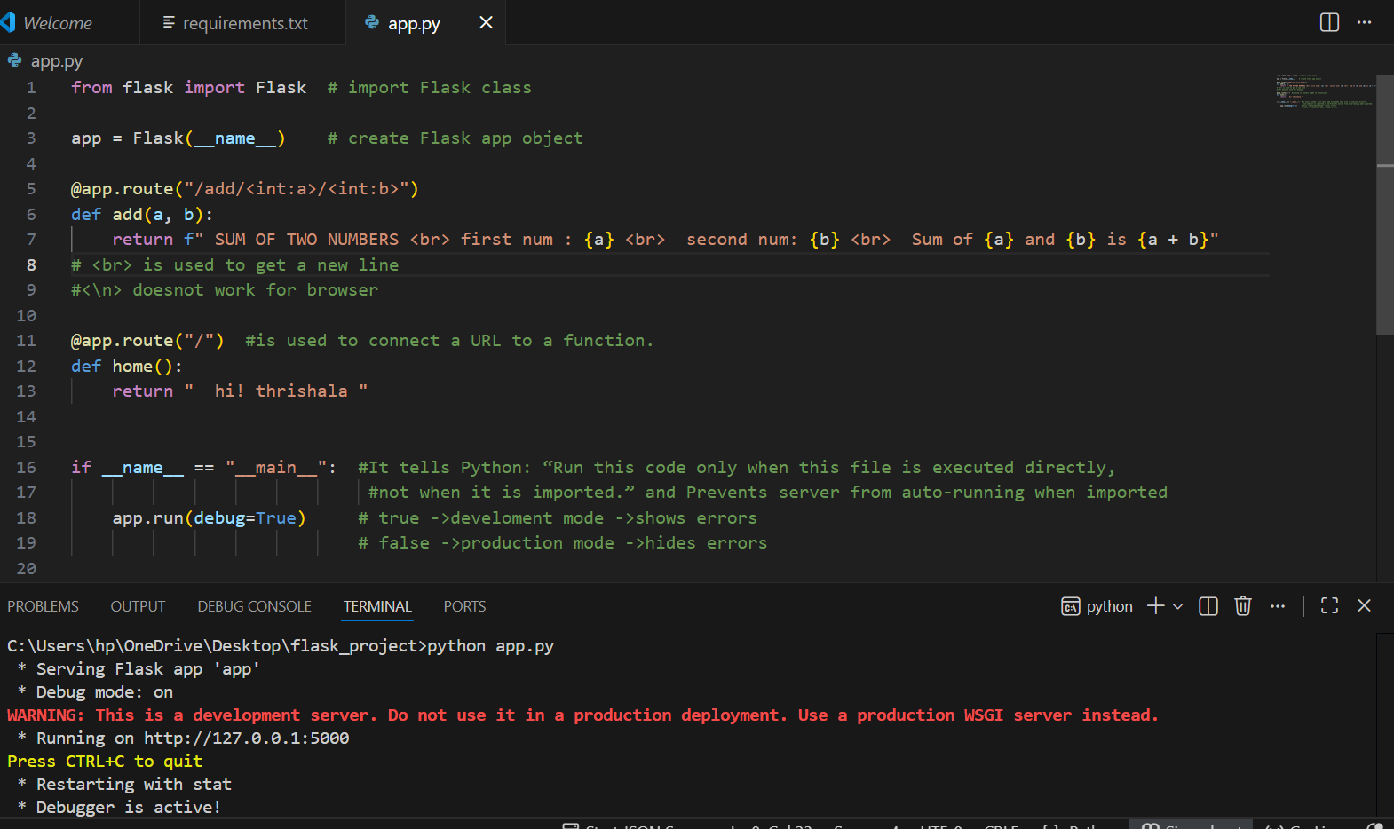
Output :
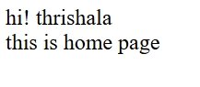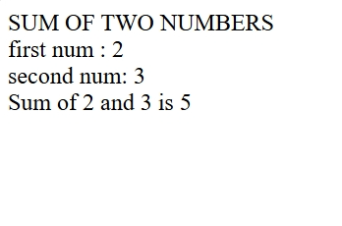

Day 7:
about milestone 1
login page:
- name
- email
- password
- preferred language
backend:
- jwt
- password hassing
Database:
- sql lite
- my sql
- mongo db
- postgre sql
user table:
column:
1) user id
2) username
3)password
4) email
Google api for login
Dashboard page:
File upload, pdf, image, scanned copy
- if already signed in then they should login no signup
- already logged in pop up

Day 8:
SQL- structured query language
It is used to share create retrieve and update data inside database
Commands:
- create -CREATE TABLE table_name ( column1 datatype [constraints], columnN datatype [constraints]);
- select – SELECT column1, column2 FROM table_name WHERE condition;
(or) SELECT * FROM table_name;
- insert -INSERT INTO table_name (column1, column2, column3) VALUES (value1, value2, value3);
- update -UPDATE table_name SET column1 = value1, column2 = value2 WHERE condition;
- delete-DELETE FROM table_name WHERE condition;
- truncate-TRUNCATE TABLE table_name;
- drop- DROP TABLE table_name;

- Not equals to --- > != or <>
- A% ---- > starts with A
- %A--- > ends with A
- %A%--- > in between there should be A
Functions:
i) order by => Sorts the final result set in ascending (default) or descending order based on specified columns.
ii) group by => Arranges identical data into groups to perform aggregate calculations on each group.
iii) MIN() => Returns the smallest value within a selected column or set of data.
iv) MAX() => Returns the largest value within a selected column or set of data.
v) AVG() => Calculates the average (mean) value of a numerical column.
vi) COUNT() => Counts the total number of rows or non-null values in a set.
Joins:
- Inner join
- Left join
- Right join
- Cross join
- Full join

Union: Combines the result sets of two or more SELECT statements into a single result set, removing all duplicate rows.
Union all: Combines the result sets of two or more SELECT statements, retaining all duplicates.
In: Allows specifying multiple values in a WHERE clause, acting as a shorthand for multiple OR conditions.
Except: Returns all distinct records from the first query that are not present in the second query.
Between: Selects values within a specified, inclusive range (numbers, text, or dates).
Like: Filters data based on a pattern search within a WHERE clause using wildcards (e.g., %, _).
Is null: Tests for empty values (NULL) in a column, as standard comparison operators do not work with NULL.
Aggregate function : An aggregate function is a function that processes a set of multiple input values (rows) and returns a single, summary value (e.g., SUM, AVG, COUNT, MIN, MAX).

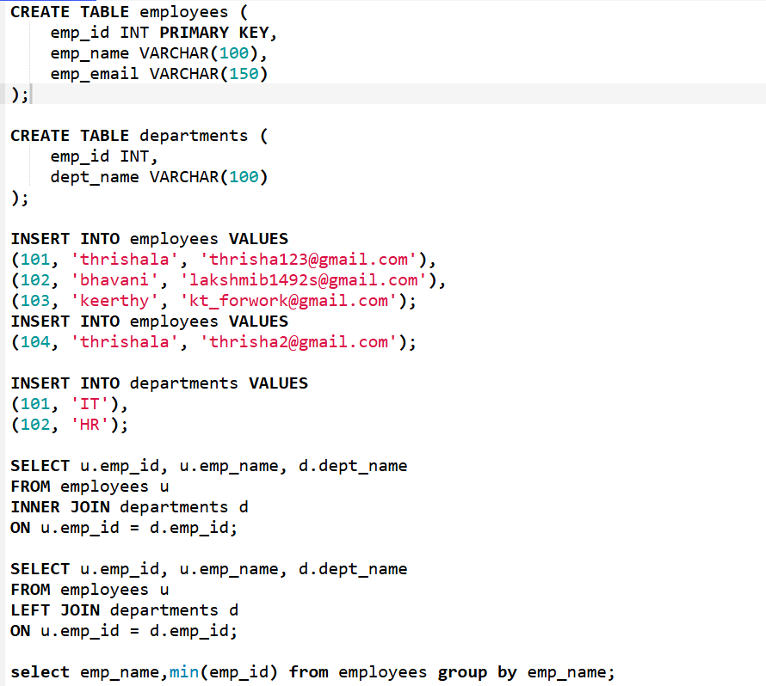

Output
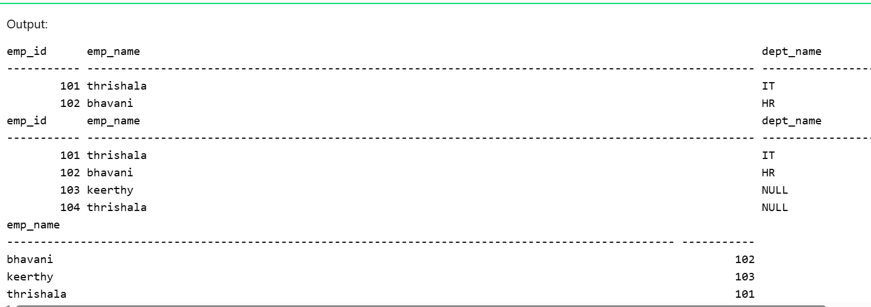

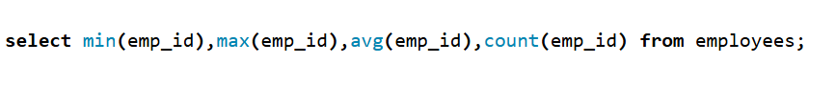
Output:
Jwt – Jason web tokens
JSON Web Tokens (JWT) are a compact and secure way to transmit information between two parties. The information is sent as a digitally signed token, which ensures that the data has not been tampered with.
How JWT Authentication Works:
- The user logs in using a username and password.
- The server validates the credentials.
- If the credentials are correct, the server generates a JWT.
- The client stores the JWT (usually in local storage or cookies).
- The client sends the JWT in the Authorization header with every request.
- The server verifies the JWT and, if it is valid, grants access to protected resources.
Implementation:
In Python, JWT can be implemented using the PyJWT library.
Install it using: pip install pyjwt
Import it in code using: import jwt
JWT authentication can also be combined with or compared to OAuth, which is commonly used for third-party authentication and authorization.
Sample code:
import jwt
import datetime // Here it helps in setting token expiry time
SECRET_KEY = "mysecretkey" // A secret password known only to the server Used to sign the JWT
payload = { // Payload = information stored inside JWT
"user_id": 101,
"username": "Thrishala",
"exp": datetime.datetime.utcnow() + datetime.timedelta(minutes=30)
}
token = jwt.encode(payload, SECRET_KEY, algorithm="HS256")
print("JWT TOKEN:")
print(token)
output:
JWT TOKEN:
eyJhbGciOiJIUzI1NiIsInR5cCI6IkpXVCJ9...
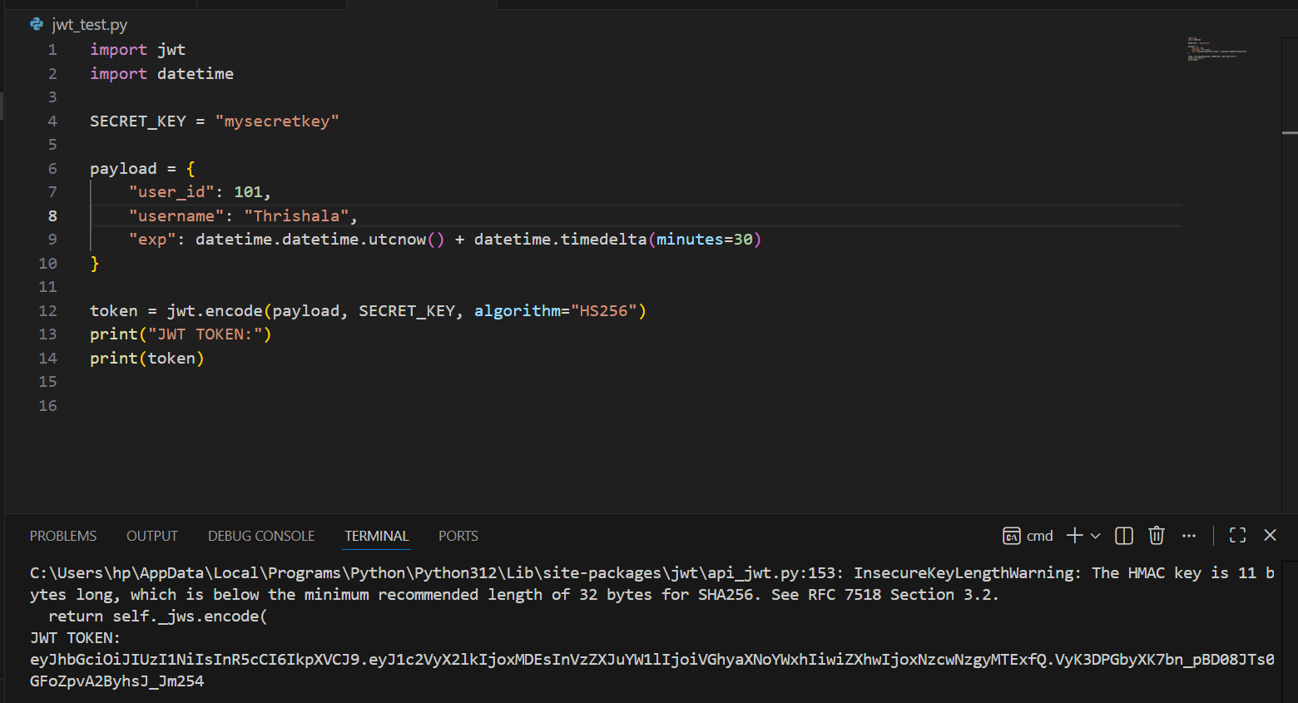

Day 9:
Hashing
1.Hashing means:
Converting a password into a fixed-length, unreadable value
It is done using a mathematical function
Important rule : Never store the original password directly in the database.
2. Hashing vs Encoding vs Encryption
🔹 Hashing
One-way process
Cannot be reversed
Used for passwords
Example: bcrypt, SHA-256
🔹 Encoding
Used to change data format
Can be reversed
No security
Example: Base64
🔹 Encryption
Two-way process
Data can be encrypted and decrypted
Needs a key
Used for secure data transfer
- Encoding and encryption can return the original data
- Hashing cannot return the original data
3. bcrypt
bcrypt is a popular and secure hashing algorithm used for passwords.
Why bcrypt is good:
Slow (protects from brute-force attacks)
Uses salt
Very secure for password storage
4. Installing and importing bcrypt
pip install bcrypt
import bcrypt
5. Password and Bytes
bcrypt works with bytes, not strings.
Example:
Copy code
Python
password = "Thrishala"
password_bytes = password.encode()
6. Salt
Salt means:
Random data added to the password before hashing
Why salt is used:
Prevents hackers from using pre-computed attacks
Makes same passwords produce different hashes
Example:
salt = bcrypt.gensalt()
=> Even if two users have the same password, their hashes will be different.
7. Hashing a password using bcrypt
hashed = bcrypt.hashpw(password_bytes, bcrypt.gensalt())
This hashed value is stored in the database.
8. Summary
- Never store plain passwords
- Use hashing for passwords
- bcrypt is best for password hashing
- Encoding & encryption can be reversed
- Hashing cannot be reversed
- Salt adds randomness and security

Built in methods in string

- strip(): Removes spaces (or specified characters) from both the very beginning and the very end of a string.
- join(): Combines a list of strings into one single string, putting a specific separator between each element.
- replace(): Searches for a specific piece of text and swaps it with new text, creating an updated copy.
- startswith(): Checks if a string begins with a specific character or phrase, returning True or False.
- endswith(): Checks if a string finishes with a specific character or phrase, returning True or False.
- find(): Searches the string for a certain value and returns the position (index) of where it first appears, or -1 if not found.
- isdigit(): Returns True if every single character in the string is a number (0-9), otherwise returns False.
- isalpha(): Returns True if every single character in the string is a letter (A-Z), otherwise returns False.

Built in methods in dictionary
- get() :Returns the value for a specified key if it exists, otherwise a default value.
- keys() : displays a list of all the keys in the dictionary.
- values(): displays a list of all the values in the dictionary.
- items(): displays a list of a dictionary's (key, value) tuple pairs.
- update(): it is used to add or modify key–value pairs in a dictionary using another dictionary or key–value pairs.
- pop() : Removes the item with the specified key and returns its value.
- popitem() Removes the last inserted (key, value) pair and returns it as a tuple.
- clear() Removes all items and elements from the dictionary.

Built in methods in sets
- add(): Adds a single specified element to the set.
- remove(): Removes a specified element; raises a KeyError if the element is not found.
- discard(): Removes a specified element if it is present; does nothing if the element is not found.
- pop(): Removes and returns an arbitrary element from the set; raises a KeyError if the set is empty.
- clear(): Removes all elements from the set, making it empty.
- union(): Returns a new set containing all elements from all sets.
- intersection(): Returns a new set containing only elements common to all sets.
- difference(): Returns a new set containing elements present in the original set but not in any of the others

Day 10 :
File input and output methods
- open(): Opens a file
- read(): Reads the entire file or a specified number of bytes from the file
- readline(): Reads one line from the file at a time.
- readlines(): Reads all lines into a list of strings.
- write(): Writes a string or bytes to the file (requires the file to be opened in write, append, or exclusive creation mode).
- Writelines():writes a sequence of strings, though it requires manually adding newline characters to each string in the sequence.
- close(): Closes the opened file.

Why there is writelines() when we already have write()?
writelines() is useful when you have a sequence of strings that you want to write to a file without explicitly looping through them . If you try to pass a list to write(), it will raise an exception because it expects a single string argument.

- len() : Returns the number of items in an object.
- range() : Generates a sequence of numbers, usually used for looping.
- print() :Outputs data to the console.
- type() :Returns the data type of an object.
- id() (ID): Returns a unique integer identifier for an object.
- uuid (UUID): Generates a universally unique identifier (requires import uuid).
import uuid; print(uuid.uuid4())
- sorted() (Sorted): Returns a new sorted list from an iterable.
- Enumerate (Enum): Creates sets of named constants
- zip() : Aggregates elements from multiple iterables into tuples.
- join() (Join): Joins elements of an iterable into a string using a separator.

Conversion functions:
- int(): Converts a number or string to an integer (int(10.5) -> 10).
- float(): Converts an integer or string to a floating-point number (float("10.5") -> 10.5).
- str(): Converts any data type to its string representation (str(10) -> "10").
- list(): Converts an iterable (string, tuple, set) into a list (list("abc") -> ['a', 'b', 'c']).
- dict(): Converts a sequence of key-value pairs (like a list of tuples) into a dictionary (dict([('a', 1)]) -> {'a': 1}).
- tuple(): Converts an iterable (list, string, set) into a tuple (tuple([1, 2]) -> (1, 2)).
- set(): Converts an iterable into a set, removing duplicates (set([1, 2, 2]) -> {1, 2}).

Mathematical functions:
- Max (max(iterable)): Returns the largest item
- Power (pow(base, exp)): Computes a number (x) raised to the power of another number ($y)$i.e. $x^{y}$
- Round (round(num, digits)): Rounds a number to a specified precision, with default rounding to the nearest integer.
- Filter (filter(func, iterable)): It selects only the required items from data based on a rule.

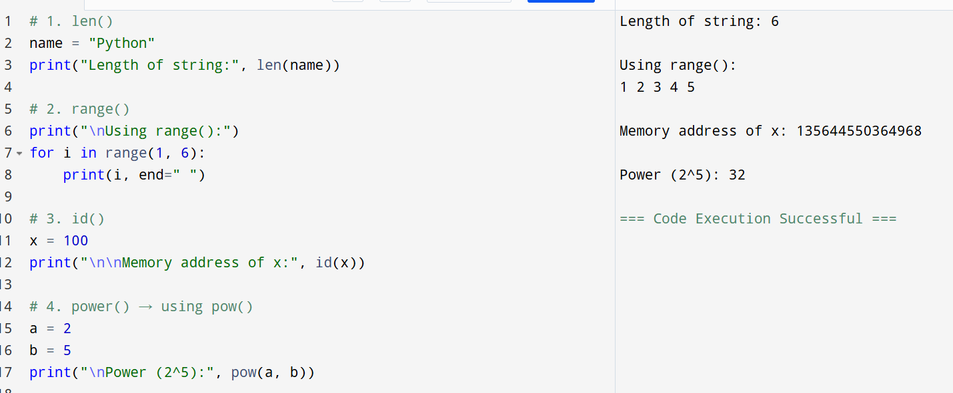

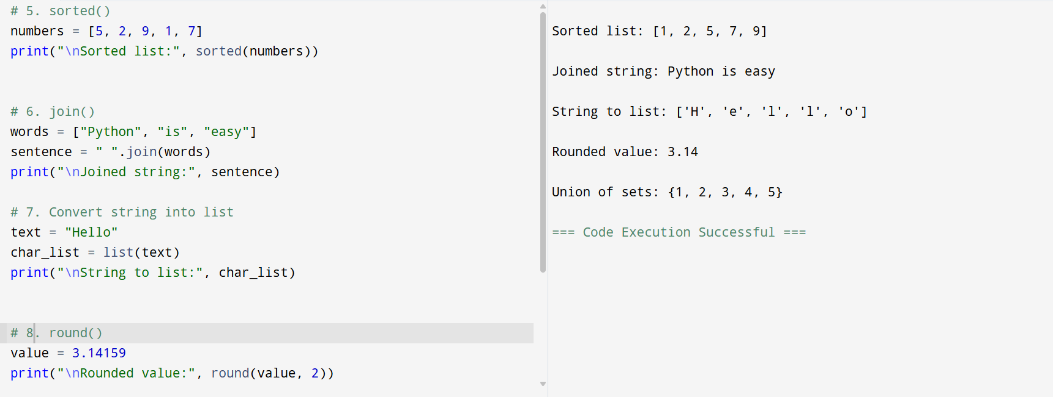

Day 11 and day 12: mildstone 1

Day13:
Class methods
- getattr(obj, name[, default]): Returns the value of a named attribute from an object, optionally returning a default value if not found.
- setattr(obj, name, value): Assigns a new value to a named attribute of an object, creating the attribute if it does not exist.
- hasattr(obj, name): Returns True if the object has the specified attribute, otherwise returns False.
- delattr(obj, name): Deletes a named attribute from an object, equivalent to the del statement.
- isinstance(obj, classinfo): Checks if an object is an instance of a specified class or a tuple of classes, returning True or False.
- Issubclass: checks if a class is a subclass of another class (or a tuple of classes).

Miscellaneous functions
- globals() → Returns a dictionary of the current global symbol table.
- locals() → Returns a dictionary of the current local symbol table.
- callable(obj) → Returns True if the object can be called like a function, else False.
- eval(expr) → Evaluates a Python expression (string) and returns its result.
- exec(code) → Executes Python statements dynamically from a string or code object.
Exception handling
- try → Write the code that might cause an error
- except → What to do if an error happens (like catch)
- finally → Code that always runs, error or no error
ex:
try:
x = int(input("Enter a number: "))
print(10 / x)
except:
print("Error occurred (maybe division by zero or wrong input)"
finally:
print("Program ended")

o/p:
if x==0
Error occurred (maybe division by zero or wrong input)
Programm ended
Assignment – 3
Enumerate:
enumerate() is used when you loop through something and want both
- the index (position)
- and the value
at the same time.
Use it when we are looping through lists, strings, tuples
Without enumerate | With enumerate
- range(len(x)) | - enumerate(x)
- More code | - Cleaner
- Error-prone | - Safe
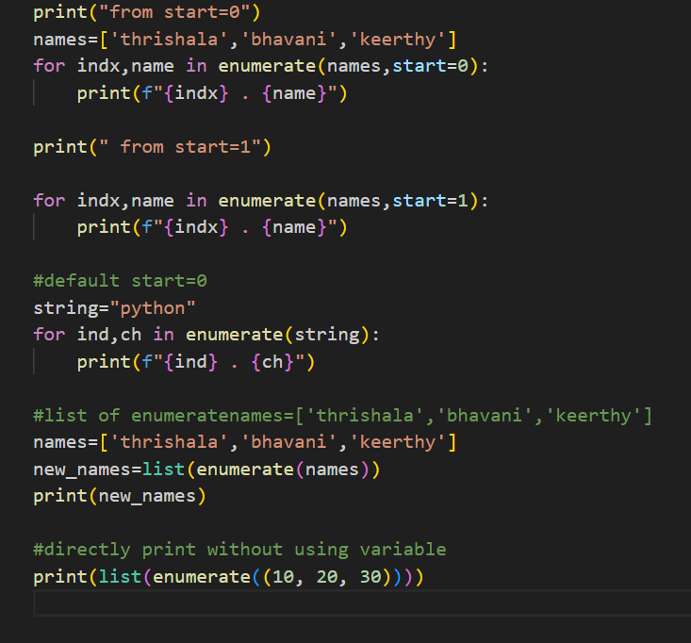
Output:
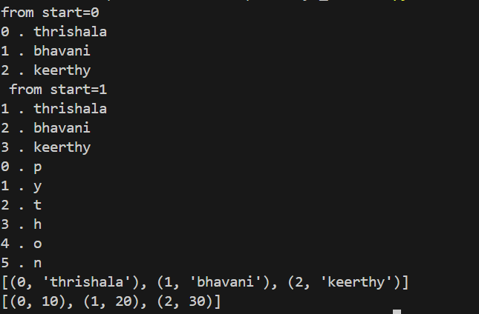

isinstance ():
isinstance() checks whether an object belongs to a specified class or data type and returns True or False.
Syntax: isinstance(object, classinfo)
object → variable / value
classinfo → data type or tuple of types
Returns True or False
Ex:
1)x = 10
print(isinstance(x, int))
o/p: True
2) class Student:
pass
s = Student()
print(isinstance(s, Student)) o/p=> True
GClibrary:
1) The gc library means Garbage Collection.
2) gc automatically cleans memory by removing objects that are no longer needed.
3) gc frees that unused memory
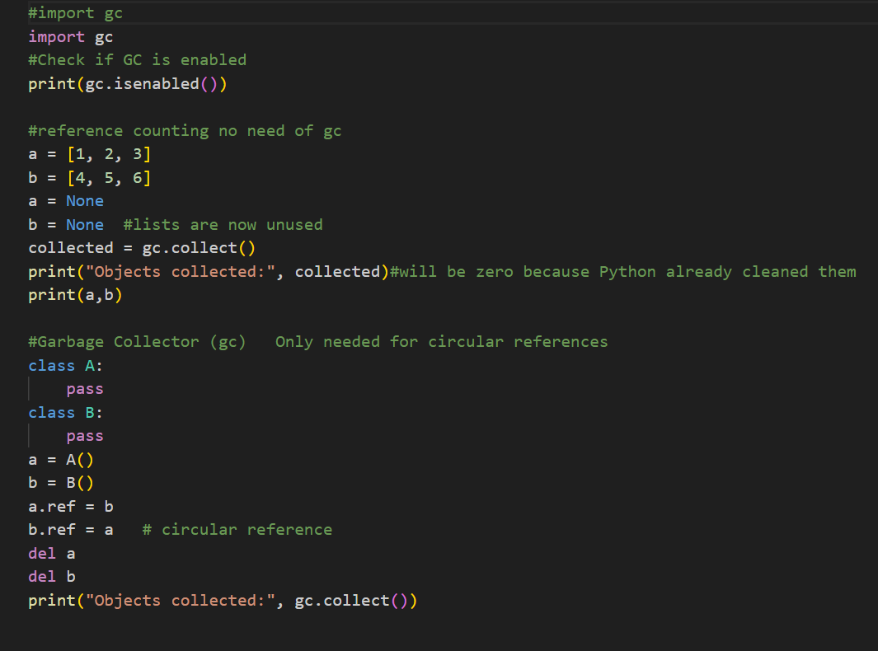

Output:
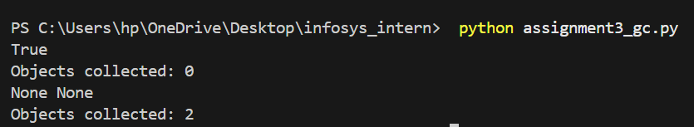

Day14:
AI models:
They are programmed and pretrained for specific purposes ,it can be chat ,image generation,prediction etc..
Prediction -> weather prediction
Image generation -> open cv(computer vision)

Platforms:
Company | Main LLM
Google - | Gemini
OpenAI - | GPT
Microsoft - | Copilot (GPT-based)
Anthropic - | Claude
Meta - | LLaMA
Amazon - | Bedrock (multi-model)

LLM(large language models):
Large Language Models are AI systems trained on massive text datasets to understand, generate, summarize, translate, and reason with language. They learn patterns in text and predict the next token (piece of text).
Token limit :maximum number of tokens (input + output) a model can handle in one request
Rate limit : how often and how much you can call an LLM within a given time window.

Chat completion component for open ai:
response=client.chat.completions.create( model: “gpt-4o-mini”,message=messages ,temperature=0.7,max-tokens=500)
Temp-> 0-1.1
creativity of model will be used with high temp;

creating api :
    - Open ai api
    - Gemini api
    - Lama api
Day15:
NLP:
it’s a subset of ai teaching computer to read and understand languages
two types of sentences : 1)positive sentence
2)negative sentence
NLTK:(Natural language tool kit)
It’s a python library used to interpret techniques
=>pip install nltk
=>import nltk
=>nltk.download(‘all’)

    - main key features:
1) Tokenization:
Tokenisation is the process of breaking text into smaller pieces called tokens so that a language model can understand and process it.
=>from nltk.tokenize import word_tokenize
2) stop word removal :
Removing stop words like is ,are,in,and
These are words that doesn’t have any meaning
This->not a stop word
=> from nltk.corpus import stopwords
3) Stemming:
It is the process of reducing a word to its root (base) form by removing prefixes or suffixes.
The root word may not be a real dictionary word.
=>from nltk.stem import poster Stemmer
4) Lemmatization:
Lemmatization is the process of converting a word into its base or dictionary form, called a lemma.
=>from nltk.stem import Word Net Lemmatizer
5) parts of speech tagging ->pos tagging
POS Tagging means labelling each word in a sentence with its grammatical role
(like noun, verb, adjective, etc.).
=>from nltk.tokenize import word_tokenize
6)NER (Name Entity Recognition)
Recognise names , place, data,organisations
=>nltk.download(‘maxent_ne_chunker’)
7)Text preprocessing
Text preprocessing means cleaning and preparing raw text so that machines can understand it better.

ASSIGNMENT 4

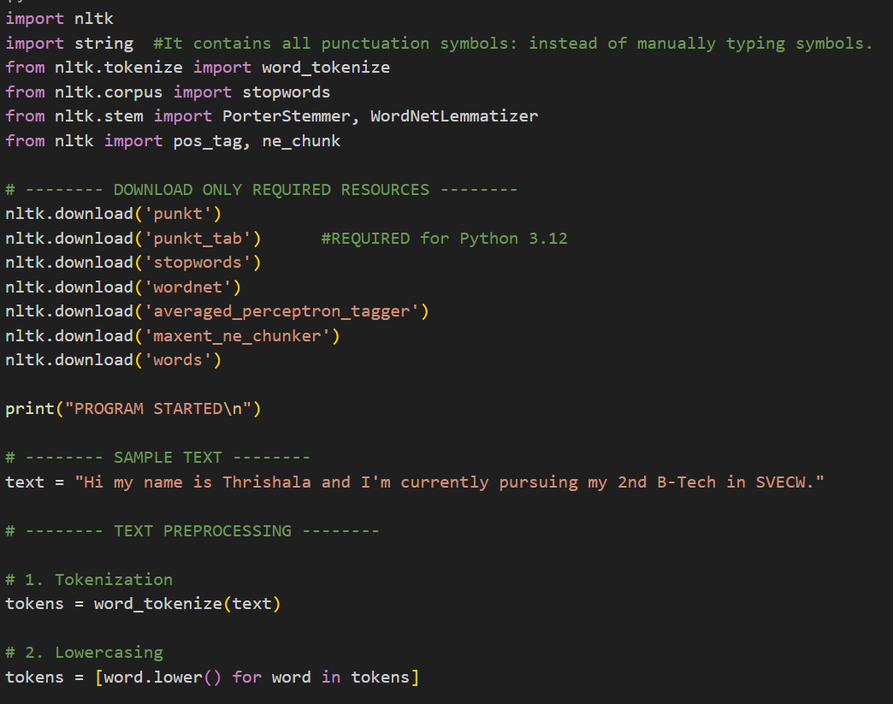
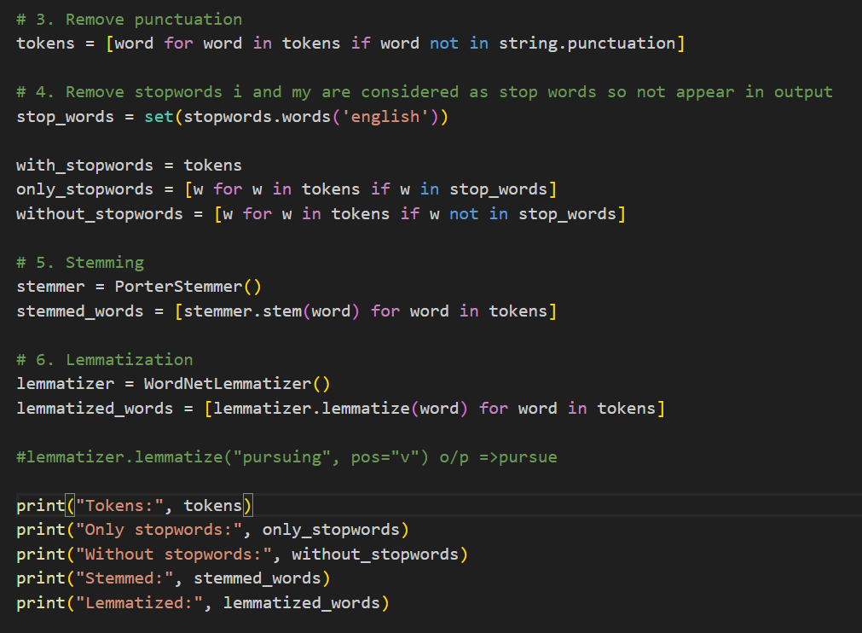

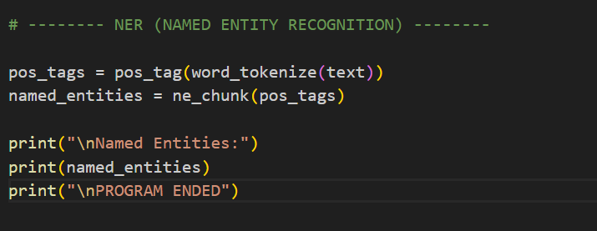
OUTPUT:
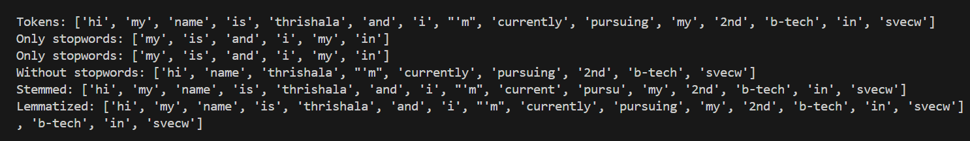
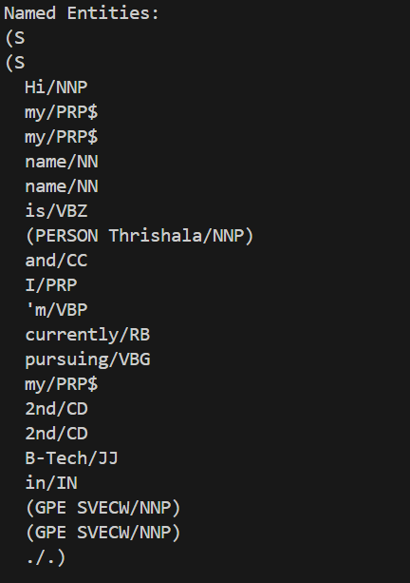

Day15:
Machine learning:
Machine Learning (ML) is a field of AI where computers learn patterns from data and make predictions without being explicitly programmed.
Types of Machine Learning
Supervised Learning
Uses labeled data (input + output).
Examples: spam detection, price prediction.
Unsupervised Learning
Uses unlabeled data to find patterns.
Examples: clustering customers, grouping data.
Reinforcement Learning
Learns using rewards and penalties.
Examples: games, robotics, self-driving cars.

Embedding
Embedding is a numerical vector representation of data (text, image, etc.) that captures semantic meaning.

Underfitting
Model is too simple and fails to learn patterns.
Low training and testing accuracy.

Overfitting
Model learns noise and memorizes data.
High training accuracy, low testing accuracy.

Logistic regression:
used to make YES/NO decisions.
- Looks at input data (marks, age, hours studied, etc.)
- Calculates a score
- Converts that score into a probability (0 to 1)
- Decides:
  - YES (1) if probability ≥ 0.5
  - NO (0) if probability < 0.5
Why is it called logistic?
Because it uses a special S-shaped curve called the sigmoid function.
This curve:
- Never goes below 0
- Never goes above 1
- Perfect for probability
Linear regression:
method used to predict a NUMBER.
        - Looks at input (hours studied, experience, area, etc.)
        - Draws the best straight line through the data
        - Uses that line to predict a number
- Linera regression because the relationship looks like a straight line:
- y = mx + c
sklearn and sckit-learn:
scikit-learn → full name of the machine learning library
sklearn → short name (nickname) used in code
import scikit-learn ❌ (not allowed)
import sklearn ✅
pip install scikit-learn ✅
pip install sklearn ❌
Python module names cannot contain hyphens (-).so sklearn instead of scikit-learn
scikit-learn (sklearn) does not provide pretrained models; it provides algorithms that must be trained on your own data.

Decision trees:
makes decisions by asking simple YES/NO questions, like a flowchart.
It works like this:
- Ask a question
- Go left or right based on the answer
- Ask another question
- Reach a final decision

OCR models:
- PaddleOCR is a deep-learning-based OCR system developed by Baidu. It is known for high accuracy and strong performance on real-world documents like bills, ID cards, signboards, and forms. It supports many languages, including English and Indian languages, and can handle printed text, some handwriting, and complex layouts.
- PyTesseract OCR is a Python wrapper for the Tesseract OCR engine. It works best for clean, simple, printed text such as scanned books or documents with good lighting and contrast. It is easy to use but not very accurate for handwriting or noisy images.
- DocTR (Document Text Recognition) is a modern OCR system based on deep learning. It not only extracts text but also understands document structure, such as lines, blocks, and paragraphs. This makes it useful for advanced document analysis, research, and layout-aware OCR tasks.
- Surya OCR is mainly focused on Indian languages and regional scripts. It is useful when working with documents in languages like Telugu, Hindi, Tamil, etc. It is often chosen for local-language digitization projects in India.
- EasyOCR is beginner-friendly and very easy to set up. It supports many languages and works well for quick OCR tasks like reading text from images or screenshots. While it is simpler than PaddleOCR, it still gives good accuracy for general use cases.

Day16:
Steps:
1) Pip install pytesseract pillow
2)then download tesseract and save it in c drive in programming files and then copy the path
3)downalod an img of invoice save it in same folder in vscode
4) now in vs code use that path and code then copy path of img in vs code and paste it in py code
5)run python app.py
Code:
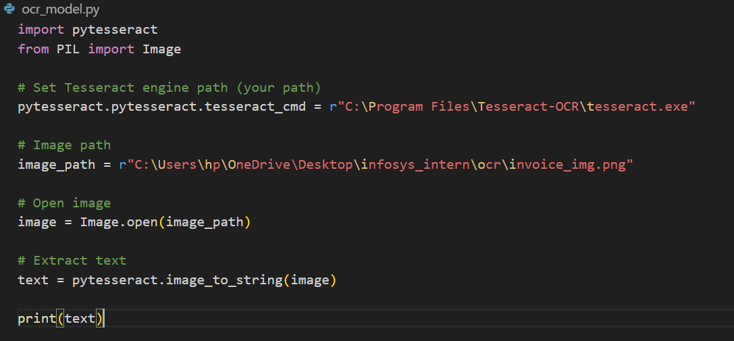
Invoice:

Output:
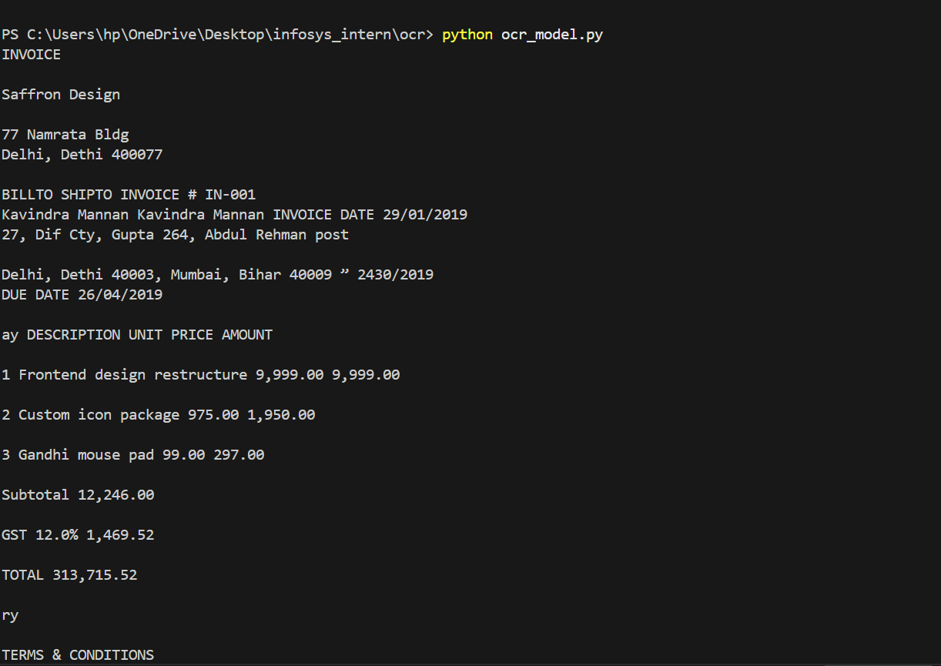
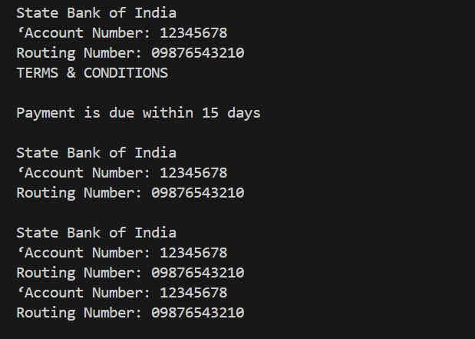
Day17:
K-Means:
K-Means is a clustering algorithm.
It groups similar data points into K groups (clusters).
Here K means how many groups you want.

🔹 Simple idea
- You choose a number K (for example, 3).
- The algorithm puts data into 3 groups based on similarity.
- Each group has a center called a centroid.

🔹 How K-Means works (step by step)
- Choose K (number of clusters).
- Pick K random points as starting centers (centroids).
- Assign each data point to the nearest centroid.
- Move the centroid to the average (mean) of its group.
- Repeat steps 3–4 until clusters stop changing.

Euclidean Distance
- Measures how far a data point is from a centroid
- K-Means assigns a point to the nearest centroid
- Most commonly used distance metric
📐 Formula:
$$\sqrt{\left(x_{2}-x_{1})^{2}+(y_{2}-y_{1})^{2}\right.}$$
👉 Smaller distance → point is more similar

Within-Cluster Sum of Squares (WCSS)
- Measures how compact a cluster is
- It is the sum of squared distances between each point and its centroid

Interpretation of WCSS
- Large WCSS → clusters are more spread out
- Small WCSS → clusters are tight and compact
- Goal of K-Means: minimize WCSS
👉 Used in the Elbow Method to choose the best value of K
Elbow Method
The Elbow Method is used to find the best value of K (number of clusters) in K-Means.
Basic idea
- Run K-Means for different values of K (1, 2, 3, …)
- For each K, calculate WCSS (Within-Cluster Sum of Squares)
- Plot K vs WCSS
- Look for a point where the graph bends like an elbow
👉 That point is the optimal K
KNN
K-Nearest Neighbours (KNN) is a supervised learning algorithm.
It predicts the output based on the K closest data points (neighbors).
K = number of nearest neighbors
Uses distance (usually Euclidean distance)

KNN for Classification
Used when the output is a category (label).
How it works
- Choose value of K
- Find K nearest data points
- Take a majority vote
- Assign the class with maximum votes

KNN for Regression
Used when the output is a number (continuous value).
How it works
- Choose value of K
- Find K nearest data points
- Take the average of their values
- Assign that average as prediction

Day17:
Back propagation
Backpropagation is an algorithm used to train neural networks.
It helps the network learn from mistakes by updating weights to reduce error.
Why is it needed?
- A neural network makes a prediction
- Prediction has an error
- Backpropagation adjusts weights to minimize this error

How Backpropagation works
1️⃣ Forward Propagation
- Input is passed through the network
- Output is predicted
2️⃣ Loss Calculation
- Compare predicted output with actual output
- Error is calculated using a loss function
3️⃣ Backward Propagation
- Error is sent from output layer to input layer
- Gradients are calculated using chain rule
4️⃣ Weight Update
- Weights are updated using gradient descent
$$\text{New weight}=\text{Old weight}-\text{Learning rate}×\text{Gradient}$$
- Loss function → measures error
- Gradient → direction of error change
- Learning rate → how fast weights change
- Chain rule → used to compute gradients

